Assignment 2

Playing with files

1. Create a file like nano file1.txt

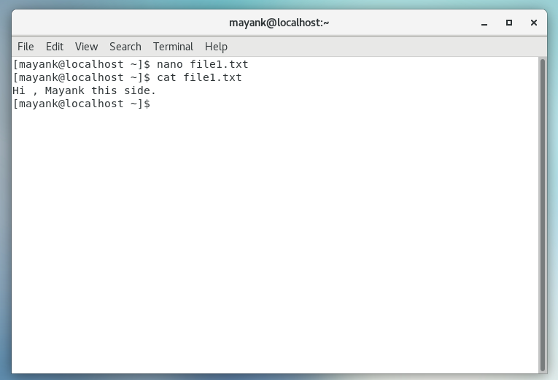

2. Now we will copy date from file1 to new file2

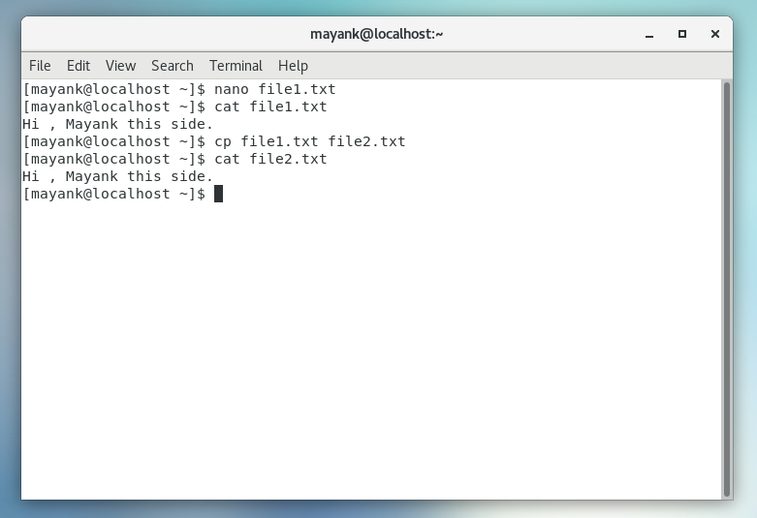

3. Then we create a new file3.txt and file4.txt in home directory and add content in it.

Difference b/w > and >> while doing echo Both > and >> are used to provide the output to a file. But > will override the existing content of file and add the new content. Whereas >> will add the new contents at end of file

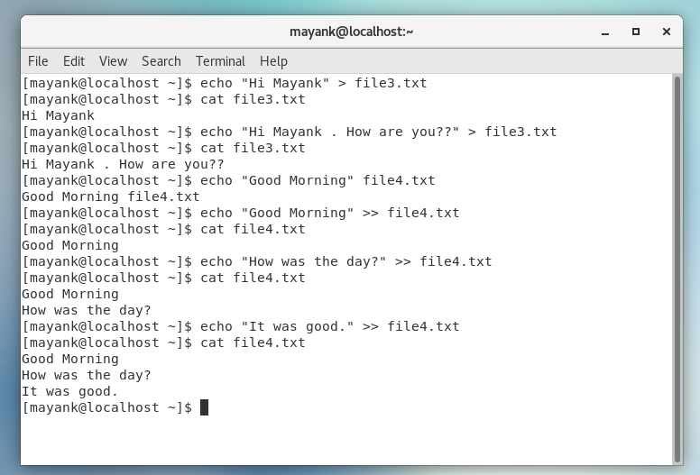

4. For remove a file or directory you can use the below two commands

